Cloud Computing Overview (AWS CLI)

HOS07: Amazon Simple Storage Service (S3)

Developed by Marvin Gold 12/20/2020

Reviewed by Kim Nguyen class of 2021

School of Technology and Computing



**Learning Outcomes**

* Create an S3 bucket
* List buckets and bucket objects
* Delete buckets
* Delete objects
* Move objects
* Copy objects

**Background**

Amazon S3 is Amazon Web Services’ storage solution that offers object level storage to users. We are going to learn how to create and manipulate “buckets”.

**References**

<https://docs.aws.amazon.com/cli/latest/userguide/cli-services-s3-commands.html>

https://aws.amazon.com/s3/

**Step 1: Log onto your Amazon EC2 Instance**

Log onto your Amazon EC2 instance using either OpenSSH, Putty, or from the AWS Management Console using ‘EC2 Instance Connect’ (shown below). Note all IP addresses used in this series of Hands on Skills will be released by the time we start class.

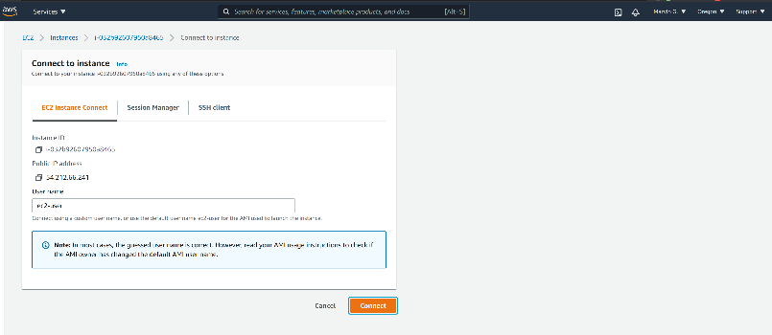

If you receive an error that you must first set your AWS Region and you must configure your AWS CLI, please follow these instructions.

<https://docs.aws.amazon.com/cli/latest/userguide/cli-configure-quickstart.html>Remember, do not use your root *account* for these operations. You should be using another IAM user. You should not have access keys to your root account.**Step 2: Create a bucket and list buckets and objects**

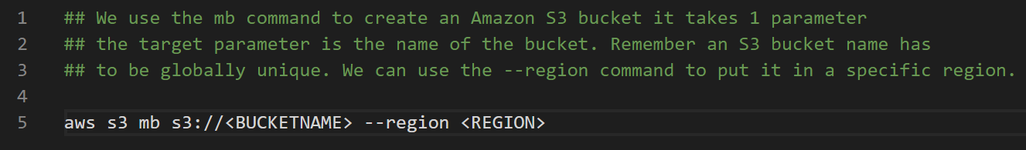

Create a bucket with a unique name, and attach a **SCREENSHOT** of the output below.

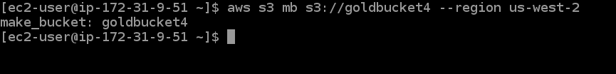



We can list buckets very similarly to how we list buckets in a Unix system. Using the LS command.

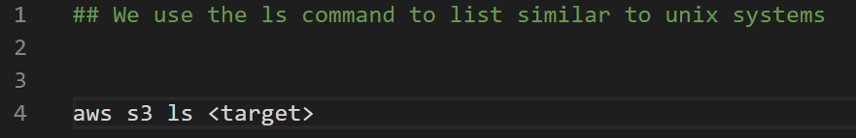

List your newly created bucket and attach a **SCREENSHOT  Note: If you use aws s3 ls with no additional arguments it will list all of your buckets.**

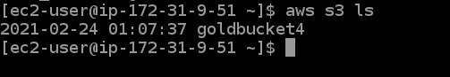

**Step 3: Bucket Manipulations**

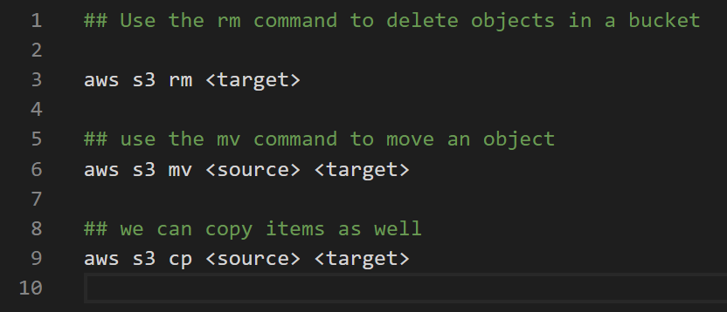

**Step 4: Challenge**

Create a text file called test.txt

Log into the AWS console and upload your test file into the bucket you created for this HOS

Using the CLI do the following:

List your bucket with the test.txt file, **attach a screenshot**

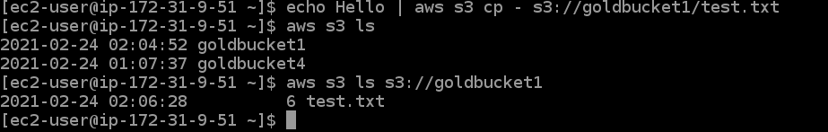

Make a copy of the test.txt file called test2.txt **attach a screenshot**



Delete the file test.txt **attach a screenshot**



**Step 5:  Delete a bucket**

To clean up we are going to delete the bucket we created

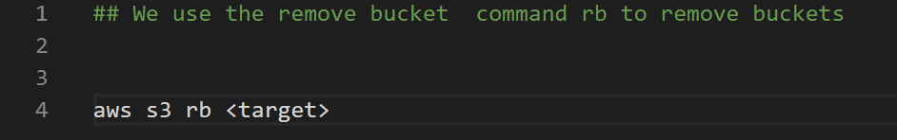

Take a **SCREENSHOT** of your output

